Standards and Quality Report – Pine Trees Nursery 2025-2026

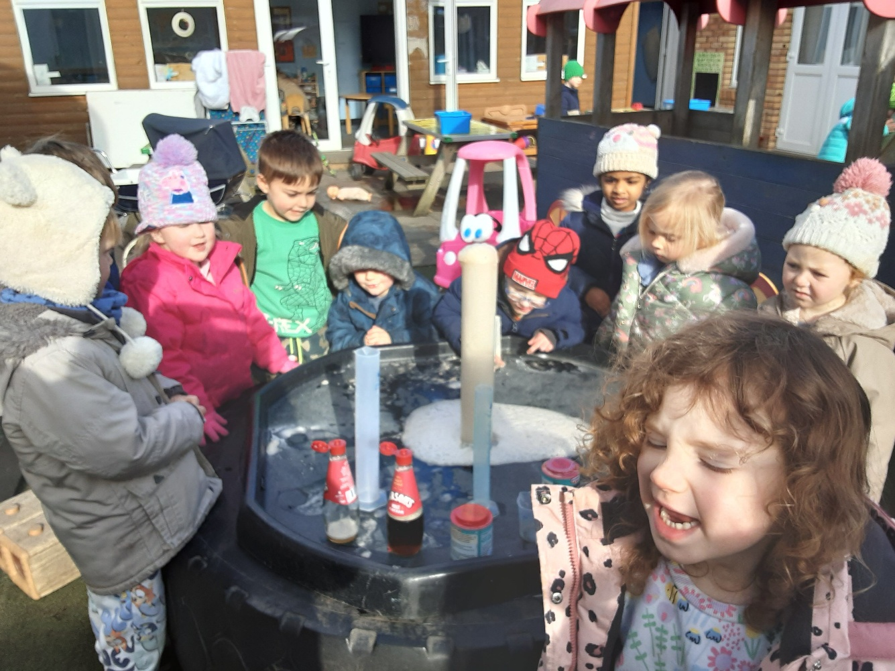

“Growing Healthy Happy Children”

Introduction

Pine Trees Nursery is a traditional building situated within the KA9 Prestwick postcode area and is accessed by families from the wider community. The setting is registered with the Care Inspectorate to provide a care service to a maximum of 98 children from 0-5 years. During Session 24-25 we provided early learning and childcare for 159 children aged 0-5 years. Children are split between 3 playrooms – 24 x 0-2 years (Buttercups), 20 x 2-3’s (Daisies) and 54 3-5’s (Sunflowers) with a team of 33 staff members. The nursery is led by a senior management team with a wealth of experience including the Nursery manager who has over 20 years’ experience in childcare. Most children accessed their funded placement only (1140 hours), including the provision of funded 2-year-old provision. The setting accommodates children from a range of backgrounds from SMID 1-8 and with a range of needs. Pine Trees is non-denominational; all children and families are welcome.

For the most recent time periods available (2024), Prestwick Locality had: A total population of 23,008 people, where 47.6% were male, and 26.2% were aged over 65. 19.3% of people lived in the least deprived SIMD quintile, and 2.5% lived in the most deprived quintile. Overall, 47.6% of the population are male, and 52.4% are female. 27.9% of the locality’s population with at least one long-term physical health condition. This is higher than Scotland (21.7%). In 2021/22, 22.2% of people were prescribed medication for anxiety, depression, or psychosis in Prestwick Locality. This is a 33.9% increase from the rate 10 years prior in 2011/12

Centre | Quintile 1 | Quintile 2 | Quintile 3 | Quintile 4 | Quintile 5 | Unknown
Centre | Decile 1  Decile 2 | Decile 3  Decile 4 | Decile 5  Decile 6 | Decile 7  Decile 8 | Decile 9  Decile 10 | Unknown
Pinetrees Early Years Centre | 11.3 | 14.2 | 30.2 | 30.1 | 14.2

11.3% of our children live in SIMD 1 & 2, this is an increase from the last year, however our team know our children and families very well and have built trusting and secure positive relationships, allowing us to know how best to support all our service users. Through a programme of extra-curricular experiences, we ensure that all our children have access to the resources, activities and support that allow them to thrive and reach their potential.

Vision

We have one main aim – to grow healthy happy children! Children thrive when they are safe, happy, loved and cared for and that is what we do well at Pine Trees.
- Our vision is to grow healthy happy children! We believe all children should have the opportunity to reach their potential and we achieve this by providing a stimulating and challenging environment, rich in opportunity where children are welcomed to feel safe, loved and cared for. We strive to create a nurturing environment where our professionally trained staff can target individual needs of children to raise their self-esteem, confidence and attainment.

As our setting has grown over the last couple of years, we have reviewed our Vision, Values and Aims in partnership with our staff, service users and partners. (May 2024)

Values
- Fairness
- Equality
- Understanding
- Honesty
- Knowledge
- Fun

Aims
At Pine Trees our aims are based on the shared values of the nursery and its wider community. The aims were developed through consultation with staff and where possible, parents.

- We aim to provide an environment in which each child can become a successful, confident, and independent learner who is achieving across a wide range of areas.

- Our priorities comply with legislation and are responsive to national and local guidelines and codes of practice.

- We encourage child led development through purposeful play in a rich learning environment.

- We aim to provide a nurturing healthy environment where children’s health & wellbeing is at the centre of practice.

- We aim to have a true partnership with parents and carers in all aspects of Early Learning and Childcare. We seek to provide additional support where needed to develop every child’s potential. We promote equality and celebrate diversity and inclusion.

- We seek to professionally support our staff and value the direct impact they have on the provision of quality of care and education. We aim to grow healthy happy staff!

Context of the Early Years Centre

Here at Pine Trees, we continue to focus on quality teaching and learning that has been refreshed in partnerships with our children, families, and partners. Feedback from partners & parents has allowed us to identify areas for improvement, such feedback includes ‘My only wish is that we would get more updates from or about changes to the key worker & ‘I would like to see more pictures of my child having fun, which I know is a catch 22 situation as practitioners will be engaging and having fun with the children which is priority ‘
30 of our children are moving into primary 1, 9 being deferred with the remainder of our children being in their ante-preschool year, the team continue to deliver the curriculum holistically and are working closely with our children & principal teacher. Most of our children remain with us until they reach their preschool year when they split between ourselves and the ELC associated with the chosen primary school. As an SVQ Approved Centre with SQA to support the delivery of Level 7 & 9 Social Services, Children & Young People, Pine Trees is a recognised Modern Apprentice Employer supporting the young workforce in partnership with Skills Development Scotland (SDS) and SQA.

Areas for improvement include:

- Tapping out syllables in words
- Identifying rhyming words
- Recognising letter symbols
- Understanding information in graphs and charts.

Developmental Milestones (% of children achieving all elements of milestone).

Centre | 2023-2024 (Achieved 8 or more June) |  |  | 2024-2025(June – Achieved 8 or more)
Centre | Health and Wellbeing | Comm. and Language | Maths and Numeracy | Health and Wellbeing | Comm. and Language | Maths and Numeracy
Pinetrees Early Years Centre | 97 | 77 | 93 | 97 | 48 | 79
Authority | 96 | 83 | 89 | 96 | 83 | 92

The staff team continue to be creative and innovative over the last year in developing outdoor learning with a focus on the importance of self-serve snack and lunchtime routines for our 2-5’ age group to support our children to be confident and independent. Menus were changed in partnership with parents to meet the newly issued Setting the Table guidance. We continue to make excellent use of our community spaces allowing our children to spend more time in a rich, natural, and sensory environment, such as the local beach, local parks, green spaces, and church hall to deliver PE. With the closure of the local pool, swimming lessons were put on hold however our Sponsored Cycle was a great success with the involvement of parents, carers, grandparents. £2000 was raised, this was used to support Zumbini, Story Telling, Football with Ayr United and baby sensory classes – these being chosen by our children.
We have achieved our bronze and silver awards with Rights Respecting School, we’re currently working towards our GOLD Award in partnership with other local early learning providers and St Patricks Primary in Troon. Our delivery of Play on Pedals on a Thursday has allowed 32 children to participate with 8 now being able to ride their bike without support. Through our Pupil Council meetings our children are confident in their learning and next steps with their voice embedded into planning proformas and brilliant books.
In our setting all staff are involved in leading change, over the next year we will continue to encourage and support staff to led aspects of the centre’s improvement plan, some staff are nominated to undertake enhanced leadership duties, this is displayed on our staff board. Staff are encouraged and supported to contribute to the development of the nursery by piloting new ways of working, sharing good practice and evaluating their work, visits to out LA partners allowed staff to think about group time experiences being led more by the child. We participated in a Collaborative Improvement visit, this was deemed a success by everyone, it allowed us to identify gaps and next steps such as moving to a new online profile provider. This will make tracking and assessment of children easier for all parties. Different staff have been involved in several external training events including Making Maths Visible, Language and Communication, Play on Pedals, Mental Health first aid, paediatric first aid as well food hygiene and infection prevention & control and effective questioning, they have shared their findings with the rest of the team. Abby is now part of a maths group within the authority to share new ideas, suggestions and hopefully deliver training externally. Children and families have been regularly consulted through parent information morning & evenings, open days questionnaires via Microsoft forms, and the use of floor books. Parent Evenings throughout the last year have been a great success and well attended. Drop in Fridays continued for the 0-2 age group. Parents can also attend to speak to their key worker on the last Tuesday of every month.
The Nursery Manager provides regular feedback from both formal and informal monitoring of playroom practice, displays, tracking and children’s progress. The progress of our children is closely monitored through monitoring and evaluation of tracking, profiles, support and challenge, staged intervention, and IEPs. Annual PDR for all staff has been carried out and identified areas for development, staff show commitment to further develop their own skills. Practitioners have been given the opportunity to ‘Step Up’ to cover annual leave, due to this the staff team are more confident in their daily role. As a team we have reflected and developed on all aspects of our learning environment and commitment to securing outcomes for our children. We have focussed on the importance of questioning. Partnership working has enhanced this year for the greater good in the bid to reduce inequalities and barriers to learning, this is supporting our children to be confident and successful learners, being able to be actively involved in all aspects of the setting.
Children are happy to come into nursery and are settled, they enjoy a range of experiences both indoors and outdoors. Relationships between staff, parents and partners has improved, 70 parent questionnaires were returned as part of our feedback process, comments received were positive and glowing.; ‘As a nervous first-time parent Pine Trees have made the transition to a formalised care setting easy and stress free for both myself and my daughter. My daughter enjoys the experiences offered and staff are approachable. Many thanks.’
An induction plan is in place for all children to ensure that they are well supported during their “settling in” period. We continue to review and focus on transitions throughout the term. Management team members and staff take time to find out about individual children’s needs and interests using a proforma reflecting the Health and Wellbeing indicators. (SHANARRI) updating this proforma allowed us to ask parents, carers ‘What matters to them?’ This information is recorded in their care and learning plans and our open-door policy allows parents to pop in to discuss progress, ideas, or concerns.
The setting uses IConnect following visits to other partners within the authority we will be transitioning over to Learning Journals for the start of the new term August 2025, this will allow the staff team to clearly use observations to track development. Parent’s most recent feedback ‘More individualised information about my child’s learning in the app/at handover as opposed to generic posts in app about activities’ Care Plan information has also been updated to allow for clear triangulation. Staff have engaged in moderation exercises to ensure consistent approaches to the curriculum in collaboration with the manager, we have opened these exercises up to include our partner providers to attend, this has been a success with positive feedback being received. August 2024, we began working in partnership with our PT Gary, Gary has been a role model to our MA’s and staff team, our children talk highly of him.
Appropriate plans are in place to support those children with additional requirements. Throughout the last year we have worked in partnership with health visitors, SLT, EAL, Education Psychology as well as the local authority staff to reduce any barriers to learning. Quarterly key worker reviews allow us to ensure that children are making good progress.
Pinetrees has fulfilled its statutory duties in relation to Care Planning, ASN legislation, GIRFEC, RtA, UNCRC, Codes of Practice, Child Protection and Data Protection (GDPR). The staff team update and review their child protection training annually in line with the local authority, any new staff are provided with this as part of an induction. The nursery manager is the nominated child protection co-ordinator, with detailed chronologies being maintained.
We have continued to focus on and support children’s metal health within the setting and through home ink activities using ‘The Colour Monster’, ‘Big Bag of Emotions’ as well as our Emotion Stations and Feelings Board. We continue to make best use of our sensory/relax area within our 3-5 playroom, all areas indoors and out have access to a quiet space.
We continue to build and retain successful relationships with staff, children, and families along with the wider community including the cluster and family of schools. Our ‘Litter Pick’ and ‘Beach Clean’ initiatives were greatly supported by the Prestwick community. Staffing has remained steady. With new students settling in we are continuing to promote a shared understanding of and importance of play pedagogy.
‘Hughie’ rabbit, ‘Omelette’ and ‘Souffle’ our backyard hens have been joined by with our pond life, successfully completing the life cycle from tadpole to frog, they continue to be popular aspects of the environment. There are clear links to personal, social and emotional development in teaching the children about caring for something which is unable to care for itself, being gentle and understanding boundaries such as how best to handle the animals. Hughie Rabbit goes home on a Friday for his weekend sleepovers.
Through relationships, enhanced transitions, and a continued focus on mental health our children are very settled and secure, they are confident and enjoy their time at nursery.


https://www.facebook.com/PineTreesNursery

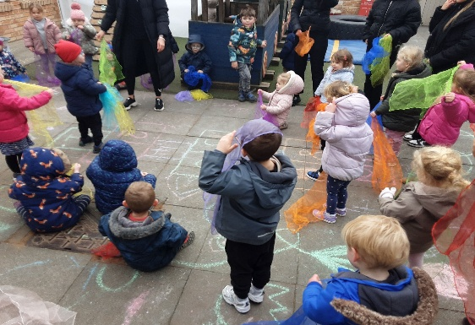
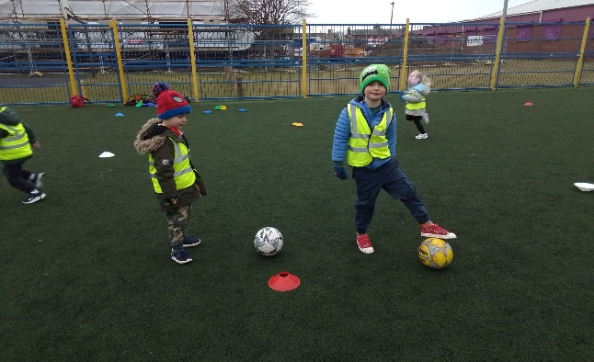
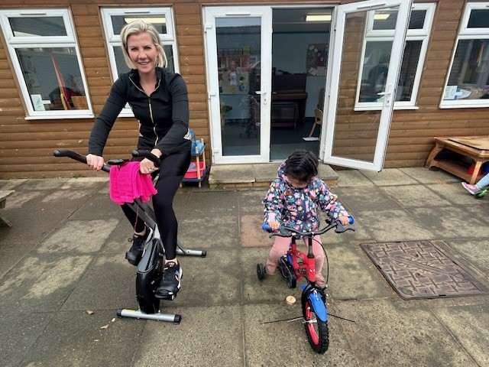
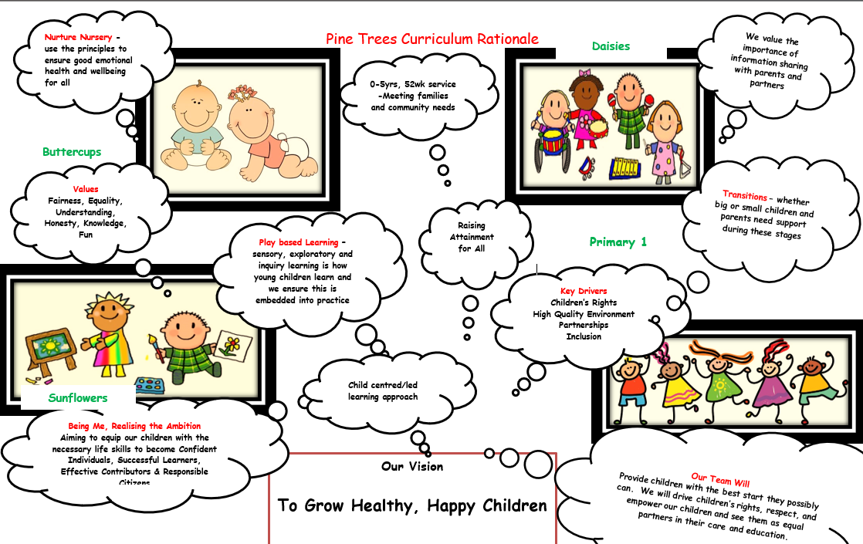

What key outcomes have we achieved?

School Priority 1: To improve attainment and secure progress in communication and early language skills
NIF Priority: Parental Engagement, Assessment of Children’s Progress, School Performance | Links to HGIOS 4 / HGIOELC  QI:-3.2 Securing Children’s Progress
Progress and Impact
Some Progress has been made to embed strategies into daily practice to secure progress in communication and early language skills. Through the continued use of the ‘Song Box’, ‘Rhyme’, role modelling, use of expressive language, Makaton, partnership working with SLT, and group story time the percentage of our children identified are making good progress.

86% of our preschool children can write for different reasons. Our Ante Pre children are continuing to be supported in using their fine motor skills through a variety of play experiences to increase their ability to recognise letters and rhyme. Our parents are engaging with us through appropriate home link exercises. The team send out regular QR codes linked to learning experiences to allow parents to continue with learning at home.
The common milestones not being achieved include ‘I can identify rhyming words’, ‘I can identify and tap out syllables in words. ‘I can recognise letter symbols’
We will continue to work in partnership with the SAC teacher to support the development of phonological awareness. 17% of our children achieved all 10 milestones., with 48% of all our children achieving the milestone.
Two members of the team have completed ‘Talk Boost’ training with one member from each discipline participating in Teacher talk training. Both have aided children’s language and communication. We continue to use Makaton daily within our practice. 1 member of the team attended communication friendly environments training.
The nursery environment and display boards are purposeful and meaningful, making appropriate use of environmental print to enhance children’s language.
Children’s profiles reflect their learning and achievements, with changes to the team it is important that the standard of profiles is consisted, feedback of profiles is provided monthly via ad hoc monitoring activities completed by the senior management team. From August 2025 the nursery will have transferred over to Learning Journals allowing the team to enhance their use of tracking and monitoring children’s progress.

Next Steps
Moving forward we will start working on the above milestones before the start of the new term to get ahead, we will continue to work in partnership with the SAC teacher. As a staff team we will continue to moderate our understanding of the milestones(monthly) to improve outcomes and reduce inequalities for all, where we can, we will continue to invite our external private partners to join the discussion. Our inhouse teacher will provide support, guidance and further explanation to our students. Staff will continue to use play as a vehicle to drive learning as well as improve and gain a shared understanding of play pedagogy.
Children will continue to be provided with opportunities to explore syllables in a variety of contexts including welcome time, snack/lunch, key worker group times, 1:1 interaction and group story sessions will continue. Book bug sessions will commence August 2025 and hopefully we will have started our communication friendly journey.
Staff will focus on their cognition of rhyme, not the creation of words that rhyme.
Key Worker review proformas have been adapted to allow keyworkers to document termly progress in relation to literacy. With the support of Learning Journals staff will be able to make better use of data.
We will continue to promote home link activities, involving parents in their children’ s learning through our Friday update email, useful links to support learning at home and the use of QR codes via learning journals.
The setting will continue to use ICT to enhance language and communication skills both indoors and out. Staff will continue to focus on supporting children to talk about their learning using questioning and prior learning using key worker floor books to summarise achievements and track achievements.
Staff will continue to self-evaluate and improve, develop and embed phonological awareness, and where appropriate use SAC screening kit to support individuals.
Look at introducing a Froebelian approach to enhance literacy skills through play.

School Priority 2 : To improve attainment and secure progress in maths and numeracy skills.
NIF Priority: Parental Engagement, Assessment of Children’s Progress, School Performance | Links to HGIOS 4 / HGIOELC  QI: 3.2 Securing Children’s Progress
Progress and Impact
Staff continue to ensure that maths and numeracy is a core element of the curriculum across the centre. The data collected at the time of transition from room to room of the M&N milestones show an increase in the percentage of children achieving M&N milestones, reflected in the percentage of children consolidating in this area of learning.
Staff are continuing to model mathematical language in play improving links between heuristic play, schemas, and early maths. 2 members of staff have completed the nurturing maths course. New resources have been purchased, and the environment has been adapted in line with this. The addition of blocks has deepened children’s learning and 100% of all children met the milestone ‘I can recognise numerals 0-10.’ Block play training has been beneficial to the whole setting, and we will continue to use it to support maths and numeracy as well as all other areas
Our collaboration inspection visit completed by SAC staff tell us that M&N is evident within indoor and outdoor environments; moderation exercises will continue to take place. The common milestones not being achieved include ‘I recognise ‘how many’ without having to count.’ & ‘I understand information in simple graphs and charts.’ ‘I can copy a simple pattern.’ We will continue to work in partnership with the SAC teacher to support the development of these milestones. 79% of our children achieved all 8 or more milestones.
Staff will continue to focus on supporting children to develop awareness of numbers, shape, counting and measuring in daily experiences with access to mathematical apparatus, experiments, baking and exploration of resources, equipment through play. The STEM station within the outdoor classroom has also supported maths and numeracy milestones. Staff have been involved in assessment and moderation activities to ensure that we are consistent in our assessment of children. 17% of all children met 8-10 milestones in maths and numeracy.

Next Steps
Staff will continue to undertake and refresh number talk training to provide them with a more in-depth investigative approach when delivering N&M, this will continue to build confidence and capacity for improvement with a focus on the above-mentioned milestones. It is important that our children are provided with experiences that provide them with the ability to apply mathematical concepts in all areas of life. A Froebelian approach will be adopted to increase the number of children meeting their milestones in maths.
Staff to look at being inventive and deliver N&M holistically through daily experiences and ensure that the quality outdoors matches that of the indoors.
Key Worker review proformas have been adapted to allow keyworkers to document termly progress in relation to numeracy. With the support of Learning Journals staff will be able to make better use of data.
As a staff team we will continue to moderate our understanding of the milestones to improve outcomes and reduce inequalities for all using play as a vehicle to drive learning. The staff team will continue to self-evaluate and improve practice.

School Priority 3 : To improve attainment and secure progress in Health & Wellbeing
NIF Priority: Parental Engagement, Assessment of Children’s Progress, School Performance | Links to HGIOS 4 / HGIOELC  QI: 3.2 Securing Children’s Progress  2.1 Safeguarding & Child Protection
Progress and Impact

A quote from our 2022 inspection report highlights that ‘Children were relaxed, happy and settled within the service. They had developed positive friendships with peers and nurturing relationships with staff. We observed happy children playing together and having fun’
A parent also shared through feedback (June 25) "Excellent nursery with happy children. Staff go above and beyond to find solutions to help children feel secure".
This element of the curriculum remains a strength in the centre with all staff striving to ensure that every child reaches their full health & wellbeing potential.
Our sponsored cycle in partnership with our parents allowed us to deliver Football lessons in partnership with Ayr united, Zumbini dance class sessions and baby sensory class. The staff continue to make excellent use of our local community spaces, providing our children with a wide range of resources and experiences that stimulate their interests, enhance play and learning opportunities. Play on Pedals continues to be popular with our 3-5’s, 16 AM and 16 PM participate. We recognise that relationships are at the heart of wellbeing and families are meaningfully encouraged to engage in their children’s learning. Through engagement, parent council meetings, open door policy and the provision of a home from home nurturing service we have continued to engage effectively with our parents.
Planning incorporates the voice of the child and is child centred to ensure that they remain interested and stimulated whilst learning, 65% of our children achieved all 10 milestones, 96% achieved 8 or more, the percentage tends to be the early years average on a consistent basis. The principles of GIRFEC are embedded into our daily practice, seeing families as active participants has built strong trusting relationships which allow for where needed early intervention being accessed including SLT, EAL and education psychology to support health, wellbeing and resilience effective plans are in place to support these children. We are very proud to have achieved our silver RRS award. Rights are embedded throughout the centre and children have a good understanding and can talk about their rights. All staff recognise and promote the rights of the child; children are more familiar in understanding their rights and responsibilities
We continue to support our ASN children with a quiet/sensor sensory room within our 3-5 area which is used effectively to support all children who need it, time to relax. Staff are more confident, and differentiation is more visible in planning ensuring all children are achieving.
The setting continues to successfully support contribute to SAC Foodbank and Toy Bank charities as well a clothing recycle programme with donations made to local establishments. Christmas 2024 was a time for giving back to our community. In partnership with St Nicholas Church, we identified 20 pensioners within the community and delivered parcels to them. June 2025, we raised £1500 to support Harbour Ayrshire in partnership with a local business.
Our Staff team continue to keep themselves up to date with current legislation, policies, and procedures in relation to Child Protection, this is updated annually and is part of the induction programme for new staff.

Next Steps
To continue to develop our extra curricula experiences such as Play on Pedals. Music – one of our parents, a music teacher will deliver Piano lessons weekly whilst continuing to use play as a vehicle to drive earning as well as improve and gain a shared understanding of play pedagogy.
We will continue to make best use of our local community and the spaces available to support the delivery of the curriculum, including the local beach, church hall and green spaces. We are also looking at re-establishing swimming lessons when Prestwick pool re opens, having been closed for refurbishment.
As a staff team we will continue to moderate our understanding of the milestones to improve outcomes and reduce inequalities for all.
Key Worker review proformas have been adapted to allow keyworkers to document termly progress in relation to HWB. With the support of Learning Journals staff will be able to make better use of data.
We will continue to welcome and support of parents and see them as partners in the delivery of our service.
As a team we need to focus more on embedding the CfE into outdoor provision, providing further breadth and challenge.

Evaluation Summary

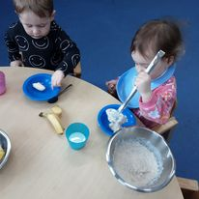

Quality Indicator | School Self Evaluation  (Please add 3 or 4 evaluative statements linked to the themes) | Evaluation (Include recent HMI / Care Inspectorate evaluations)
1.3 Leadership of change | Developing a shared vision, values and aims relevant to the school and its community.  We promote, sustain and are committed to a shared vision that reflects the best possible standards for our children, families, partners and the wider community. Children and families are involved in the design and review of our vision, values and aims. (May 2025)  We have one main aim – to grow healthy happy children! Children thrive when they are safe, happy, loved and cared for and that is what we do well at Pine Trees.  From our last inspection report: ‘Staff recognised the value of a partnership approach with parents and worked hard to build trusting relationships.  Our vision is to grow healthy happy children! We believe all children should have the opportunity to reach their potential and we achieve this by providing a stimulating and challenging environment, rich in opportunity where children are welcomed to feel safe, loved and cared for. We strive to create a nurturing environment where our staff can target individual needs of children to raise their self-esteem, confidence and attainment.  “Growing Healthy Happy Children”  Our vision drives forward our ambitious outlook for our children and families and is embedded in our practice.  We are an accredited Rights Respecting nursery school with a silver award and are working towards gold. Children’s rights are at the heart of our centre and the golden thread that is weaved throughout all that we do. Our vision, values and aims form part of our curriculum rationale.  Staff are empowered to lead change and take forward improvement priorities across the centre. Leadership opportunities are encouraged and fully supported.  Most staff are effective at assessing children’s development which enables them to identify challenges or barriers and work creatively to develop strategies and supporting materials.  We know our communities very well and have struck up meaningful partnerships with families and partners. These partnerships are key to delivering and designing our curriculum to meet the needs of our children and families.  The SMT create conditions where all people feel confident to initiate well informed change and share responsibility for the process. This helps us know what I important when meeting the needs of our children and families.  Next Steps  To continue to use staffing skills and strengths effectively to ensure that we are continuing to close the attainment gap for all.  Staff to continue to collaborate, reflect and listen to our children to improve environments for all service users.  Continue to support staff with time and opportunities to lead.  Grade - Good
2.3 Learning and teaching | Children are successful, responsible and confident in their play because of the range of experiences we offer. Their skills in language, literacy and numeracy are enhanced through play and learning experiences.  The recently refreshed curriculum rationale enables all staff and partners to share our values and the key drivers for our children.  Most staff are committed to ensuring children know and understand their rights. We have achieved silver status and are working towards gold. There is a rights group for children to ensure their voice is heard and they are empowered and inspired.  Children design the curriculum through responsive planning and rights, and we have made improvements to our approaches to responsive planning putting children at the heart of learning and empower children to lead learning. Most staff are effective in observations and use these to follow children’s interests and motivations giving depth to their learning experiences.  Hughie’ our pet rabbit, Omelette and Souffle continue to be very popular, our children have learned lots, engaged and are keen to interact and take care of them.  Regular Key Worker reviews with staff allow us to identify individual children that may require support, staged intervention and personal plan are updated in partnership with parents. We have an established monitoring process and calendar; this allows all staff to contribute to the self-evaluation process and identify any improvements.  Next Steps  Continue to support the staff team to use data effectively and use assessment information with children and their parent to plan experiences to help children to continue to make progress and deepen their learning. Implement a Froebelian Approach to learn through play. Changing to learning journals will support this as well as support us to make use of an effective system that will monitor, record, evaluate and report on progress across all areas of the curriculum, this will be discussed with induvial key workers quarterly a part of the review process.  Continue to use a holistic approach to learning, teaching and assessment.  To make better use of tracking systems to inform pedagogy and ensure that we provide breadth, depth and balance across the curriculum for all children.  Grade - Good
3.1 Ensuring wellbeing, equity and inclusion | At Pine Trees, we fully understand that positive relationships lie at the heart of children’s development and lay the foundation for lifelong learning and wellbeing. The wellbeing of children and families is paramount and is central to the work in our setting. Relationships are based on honesty and trust and getting it right to improve outcomes for children and families.  Every child is valued as an individual with their own personality, view, needs and rights. We promote and support our children to be safe, healthy, achieving, nurtured active, respected, responsible and included.  GIRFEC lies at the heart of the centre and staff use the principles of GIRFEC throughout their practice. Children’s learning needs and targeted support are identified early, we make effective use of the national wellbeing indicators to provide a holistic assessment of children’s strengths and support needs. Children’s rights are embedded into daily practice.  Children are aware of their rights and staff treat children as individuals within the centre and children are involved in many areas to improve the centre and their community. We value diversity and challenge discrimination. Our More information about me paperwork allows us to focus on what matters to parents further promoting our partnership with parents to promote and support diversity. Our children and families are valued and treated with respect. Staff know all children and families well.  Next Steps  Achieve our Gold RRS award  Continue to work in partnership with external agencies to ensure that our children benefit from the right support at the right time.  Grade 4 (Good)
3.2 Raising attainment and achievement | Securing children’s progress  Pine Tress is committed to improving outcomes for all children.  In Health and Wellbeing 96% (28) pre-school children achieved 8-10 milestones and almost all pre-school children made good progress in Health and Wellbeing across the curriculum.  In Communication and Language milestones 48% (14) pre-school children achieved 8-10 milestones and 51% were working towards (15)  In Maths and Numeracy 79% (23) of pre-school children met 8 - 10 milestones and half the pre-school children made good progress in Numeracy across the curriculum.  We strive to do the best we can for all children and staff are very creative with the delivery of experiences for our children to ensure depth and progression in learning. We have worked hard to ensure learning is differentiated to support the needs of all our learners and this is visible in planning. Our staff contribute well to ensuring those children who need additional support have the appropriate staged intervention targets and plans to ensure they are making progress.  We work very effectively with families and other professionals to identify and deliver meaningful learning opportunities. We make professional judgements about children’s progress and how well children are learning and developing ensuring that they acquire the necessary knowledge, skills and attitudes needed to continue to be motivated, life-long learners.  We place high value on recognising, capturing and celebrating children’s individual achievements. We understand the significance of what happens beyond our setting, at home and within other provisions. We use this information very well to promote achievement and progress. We have a supportive and inclusive ethos with a strong climate of mutual respect and trust. Achievements within Pine Trees are celebrated and shared with families through I Connect, Wall Displays and Care Plans.  We work in partnership with a range of services to ensure all children get the right support when they need it  Next Steps  Use Learning Journals effectively and fully to allow the team to assess and monitor progress well. We will track broad general education termly and milestones monthly.  Continue with home link exercises.  Continue to work in partnership with agency staff for the greater good of our children.  Look at Nurture Principle 1: Children's Learning is understood developmentally  Focus on Phonological awareness in partnership with both our inhouse and SAC PT.

What are the key priorities for improvement in 2025/2026?

Within Pine Trees our priority will always be to the delivery of a high-quality service. Ongoing support will be given to staff to continue to deliver high quality education and care. Our Centre Improvement Plan will continue to address the needs of our Centre whilst reflecting local and national priorities.
Leadership at all levels along with clear roles and responsibilities for the staff team allows Pine Trees to strive for excellence regarding Leadership & Management. The staff will be encouraged and supported to contribute to the development of the nursery by piloting new ways of working, sharing good practice as well as reflecting and evaluating their work.
We will continue to strive to close the attainment gap while improving outcomes for all children and young people. We will continue to focus on raising attainment in literacy, numeracy and health and wellbeing across the centre through targeted supports and interventions with a focus on phonological awareness and number work. We will also continue to provide experiences and opportunities for children to develop their Broad General Education through the methodology of cross curricular learning.
A positive ethos and building good relationships will continue to underpin all the work we do at Pine Trees; we look forward to the new term.

What is the capacity for improvement?

The manager is knowledgeable, competent, and experienced as well as committed to Pine Trees and leading development. Despite our staffing changes the senior management team has remained the same, together the management team and principal teacher are able to provide support, guidance and mentoring to our new inexperienced staff members.
.

‘Growing Healthy Happy Children’


