.

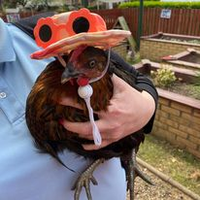

Improvement Plan 2026-2027

Pine Trees Nursery Improvement Plan
2024-2025






Our Vision Statement

We have one main aim – to grow healthy happy children! Children thrive when they are safe, happy, loved and cared for and that is what we do well at Pine Trees.

To nurture healthy, happy children through a child-centred Froebelian approach. We support every child’s unique potential through play, exploration and meaningful connections with nature. We create a warm, safe and nurturing environment where children feel valued, build confidence, and develop a lifelong love of learning

As our setting has grown over the last couple of years, we have reviewed our Vision, Values and Aims in partnership with our staff, service users and partners. (May 2026)

“Growing Healthy Happy Children”

Our Values
- Fairness
- Equality
- Understanding
- Honesty
- Knowledge
- Fun
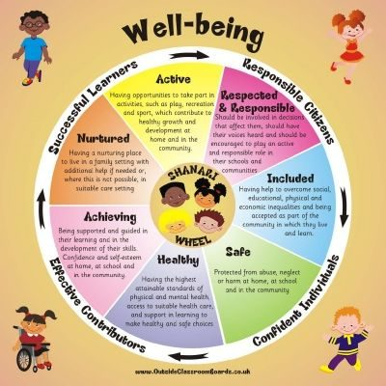

Our Aims

At Pine Trees our aims are based on the shared values of the nursery and its wider community. The aims were developed through consultation with staff and where possible, parents.

- Provide a nurturing, child centred environment

- Support learning through play and exploration

- Promote children’s health and wellbeing

- Work in partnership with parents and carers

- Celebrate equality, diversity, and inclusion

- Deliver high-quality care and education through skilled staff

- Children’s choice and voice is valued and respected

- Build strong, caring relationships where children feel safe, secure and valued.

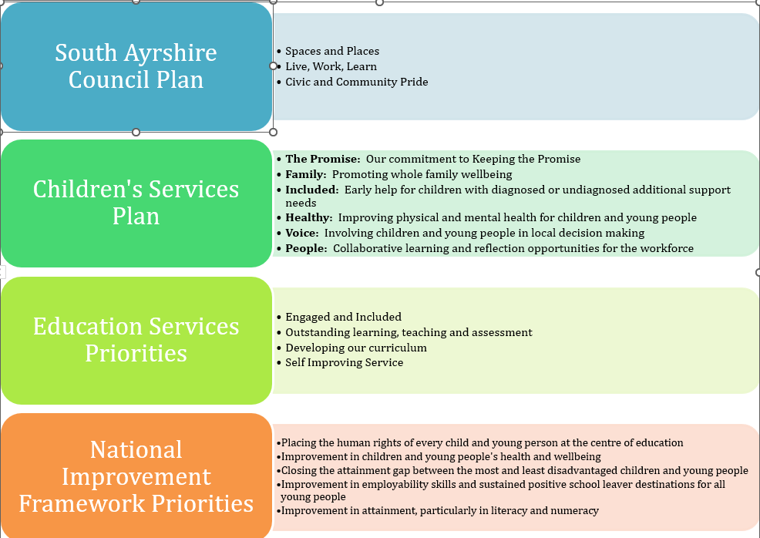

Priority 1: Improvement in Attainment, particularly in literacy & numeracy

What Outcomes Do We Want to Achieve? | How Will We Achieve This?  (Intervention Strategies) | Lead Person | Start and Finish Dates | How Will We Measure Impact on Children and Young People?  (Include Where Possible Current Measure and Target)
Develop consistent approaches to phonological awareness and early numeracy across all pre-school learners. | Track progress in phonological awareness and number milestones monthly using learning journals  Staff training, targeted group work, and high-quality learning experiences.  Ensure high-quality indoor and outdoors, play-based learning is consistent  Moderation of Milestones  To effectively use ICT to support maths and numeracy – access learning library resource.  Book Bug Sessions  Talk Boost | All Staff  Diane/SLT/Gary  All Staff  All Staff  Chris  Karen  Rosie | Aug 2026 – Aug 2027 | Quality Assurance - Monitoring of practice in relation to questioning and interactions will allow us to identify where additional support is required  80% of preschoolers will achieve ‘I can identify words that start with the same sound’, current measure – 74.2%  85% of preschoolers will achieve; ‘I can recognise letter symbols’, current measure 83.9%  90% of preschoolers will achieve 8 or more milestones in literacy – current measure 87.1%  Monitoring of planning and keyworker floor books will show that offered experiences support and challenge as well as offer progression and depth of the curriculum.  90% of preschoolers will achieve, I can recognise ‘how many’ without having to count.’, current measure 83.9%  90% of preschoolers will achieve ‘I can understand information in simple graphs and charts.’, current measure 87.1%  90% of preschoolers will achieve ‘I can recognise numerals 0-10’, current measure 87.1%  90% of preschoolers will achieve 8 or more milestones in maths – current measure is 87.1%

Priority 2: Integrate creative activities into experiences for children to foster a holistic learning environment

What Outcomes Do We Want To Achieve? | How Will We Achieve This?  (Intervention Strategies) | Lead Person | Start and Finish Dates | How Will We Measure Impact On Children and Young People?  (Include Where Possible Current Measure and Target)
Incorporating the arts, music, storytelling etc the children will engage in creative thinking, reinforcing learning in literacy, creative writing, maths & HWB | - Film making  - Drama  - Photography  - Music – Piano Lessons  - Froebelian Approaches – Weaving, Sewing, Clay & Woodwork  - Pine Trees Fashion Show | Gary P/T  All Staff | Aug 2026-Aug 2027 | 90% of preschoolers will achieve 8 or more milestones in literacy  90% of preschoolers will achieve 8 or more milestones in maths
Improve literacy & numeracy through creativity | - Helicopter Stories  - Baking  - Cooking  - Gardening & Growing  - Froebelian Principles | All Staff | Aug 2026-Aug 2027 | Improved literacy with 90% of pre school children obtaining ‘good’ across the 4 stages of learning

Priority 3: To support our children and family’s mental health and wellbeing to improve attainment and close the poverty related gap

What Outcomes Do We Want To Achieve? | How Will We Achieve This?  (Intervention Strategies) | Lead Person | Start and Finish Dates | How Will We Measure Impact On Children and Young People?  (Include Where Possible Current Measure and Target)
To develop centre approaches to teaching and assessment. | - Moderation Exercises  - Key Worker Review Process  - Termly curriculum tracking | Diane McCarrell  Alison Duncan  All Staff  Gary Train | Aug 2025 – Aug 2026 | Key Worker Review conversations will also support the % of children meeting milestones.
To support all staff to make better use of Data to reduce the attainment gap | - Learning Journals  - Access to onsite PT as with as LA PT  - Key Worker Review Process | Diane McCarrell  Alison Duncan  Senior Staff | Aug 2025 – Aug 2026 | Reliable and Robust Data, inform next steps for children and families.
To further support our children to understand their rights. | - To work in line with Rights Respecting School.  - Work towards our Gold rights respecting award. | Samantha McLure (Lead)  All Staff | Aug 2025 – Aug 2026 | Through their rights being embedded we will see HWB milestones improving.
For all staff to become aware of the changes to the CfE | - Updates and training from the authority and Education Scotland | All Staff | Aug 2026-Aug 2027 | Ensuring that children continue to receive a BGE.

Our Improvement Plan will be emailed out to our service users at the start of the new term, August 2026, our plan has been discussed with our parent and pupil committee as well-being clearly displayed around the environment. The plan will be published on our website.

Nominated staff will continue to monitor and review our improvement plan quarterly, this has been embedded into our monitoring calendar.
Appendix 1

Maintenance Agenda Some of this is in as new priorities.
Continue to reflect upon and develop Creativity using the My Creative journey and any other key documents
Continue to reflect upon and develop Outdoor Learning with staff using the ‘My World Outdoors’ document and any other key documents
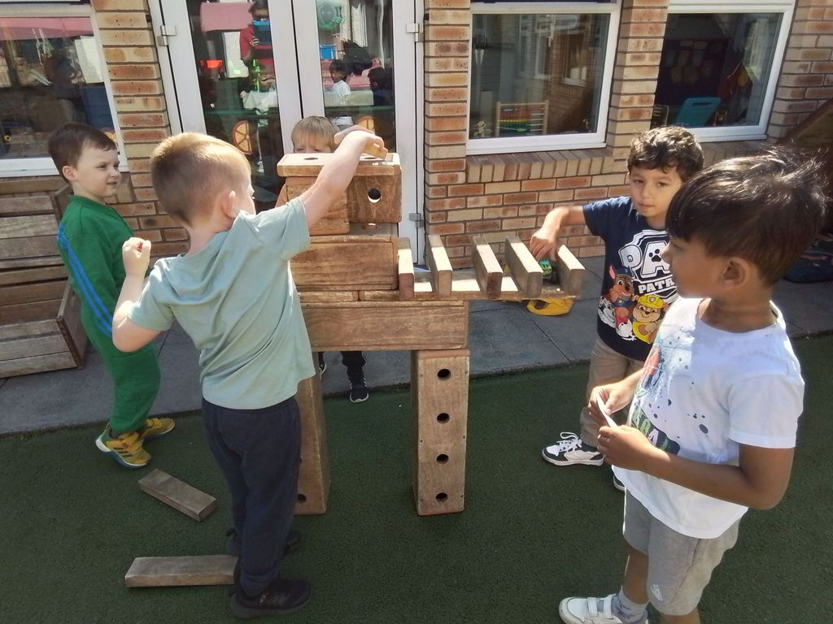
Staff self-evaluation to continually improve practice, Key Worker Review, Peer Assessment & Annual PDR programme
Observation, Moderation and Assessment Activities
Review and update planning proformas
Froebelian Principles in practice.
Onsite PT & LA PT
UNCRC rights respecting GOLD school award.
Termly Data
Weekly discipline meetings
Zumbini
Improved use of ICT
https://education.gov.scot/improvement/learning-resources/numeracy-professional-learning-resource/
Book Bug
Talk Boost

‘Growing Healthy Happy Children’

