.

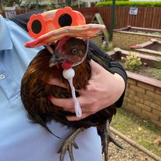

Improvement Plan 2025-2026

Pine Trees Nursery Improvement Plan
2024-2025
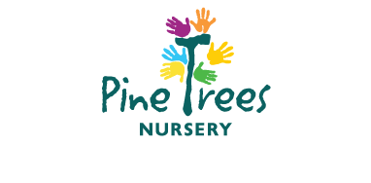





Our Vision Statement

We have one main aim – to grow healthy happy children! Children thrive when they are safe, happy, loved and cared for and that is what we do well at Pine Trees.
- Our vision is to grow healthy happy children! We believe all children should have the opportunity to reach their potential and we achieve this by providing a stimulating and challenging environment, rich in opportunity where children are welcomed to feel safe, loved and cared for. We strive to create a nurturing environment where our professionally trained staff can target individual needs of children to raise their self-esteem, confidence and attainment.

“Growing Healthy Happy Children”

As our setting has grown over the last couple of years, we have recently reviewed our Vision, Values and Aims in partnership with our staff, service users and partners.

Our Values
- Fairness
- Equality
- Understanding
- Honesty
- Knowledge
- Fun
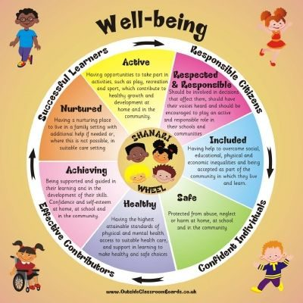

Our Aims

At Pine Trees our aims are based on the shared values of the nursery and its wider community. The aims were developed through consultation with staff and where possible, parents.

- We aim to provide an environment in which each child can become a successful, confident, and independent learner who is achieving across a wide range of areas.

- Our priorities comply with legislation and are responsive to national and local guidelines and codes of practice.

- We encourage child led development through purposeful play in a rich learning environment.

- We aim to provide a nurturing healthy environment where children’s health & wellbeing is at the centre of practice.

- We aim to have a true partnership with parents and carers in all aspects of Early Learning and Childcare. We seek to provide additional support where needed to develop every child’s potential. We promote equality and celebrate diversity and inclusion.

- We seek to professionally support our staff and value the direct impact they have on the provision of quality of care and education. We aim to grow healthy happy staff

Centre | Quintile 1 | Quintile 2 | Quintile 3 | Quintile 4 | Quintile 5 | Unknown
Centre | Decile 1  Decile 2 | Decile 3  Decile 4 | Decile 5  Decile 6 | Decile 7  Decile 8 | Decile 9  Decile 10 | Unknown
Pinetrees Early Years Centre | 10 | 19 | 14 | 31 | 25
Authority | 22 | 23 | 27 | 13 | 13

Developmental Milestones (% of children achieving all elements of milestone).

Centre | 2023-2024 (Achieved 8 or more June) |  |  | 2024-2025(June – Achieved 8 or more)
Centre | Health and Wellbeing | Comm. and Language | Maths and Numeracy | Health and Wellbeing | Comm. and Language | Maths and Numeracy
Pinetrees Early Years Centre | 97 | 77 | 93 | 97 | 48 | 79
Authority | 96 | 83 | 89 | 96 | 83 | 92

From the data collected we have noted that the centre roll has remained steady, the centre can accommodate 24 0-2’s, 20 2-3’s and 54 3-5’s. 35% of our children live between deciles 1,2,3 with the higher percentage of our children living in deciles 7 & 8. We currently have 1 care experienced child in our care. Attendance in the last term has remained steady averaging 92% Our achievement of milestones, we can only presume this is due to having a higher number of pre-schoolers this year, year around these drops with more ante pre children being accommodated, this is above the local authority percentage. Milestones identified for improvement are like that of the local authority.

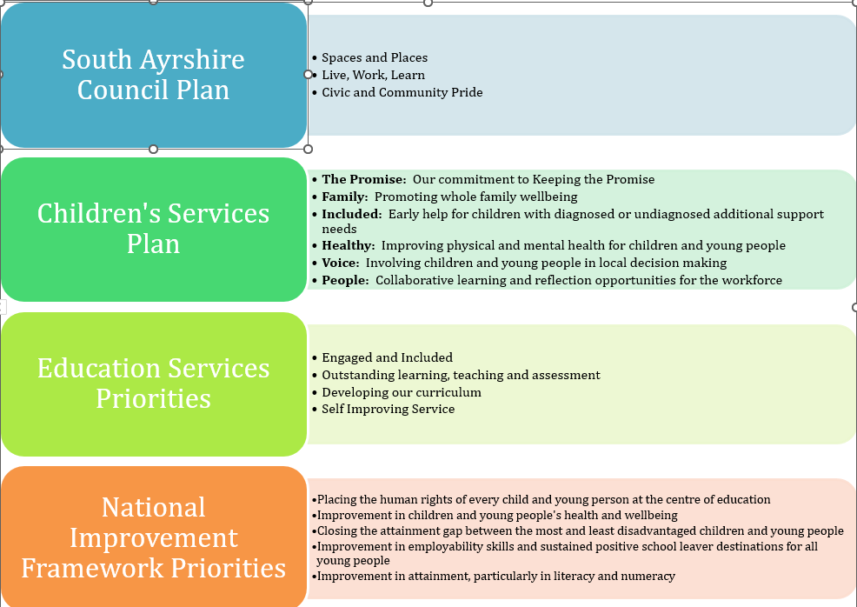

Priority 1: Improvement in Attainment, particularly in literacy & numeracy
Link to NIF: - School Improvement
HGIOELC:-1.2, 2.6 & 3.3

What Outcomes Do We Want to Achieve? | How Will We Achieve This?  (Intervention Strategies) | Lead Person | Start and Finish Dates | How Will We Measure Impact on Children and Young People?  (Include Where Possible Current Measure and Target)
Children’s will experience interactions that are appropriate and support challenge, learning & engagement.  Children can talk confidently about what they are learning | Implement evidence-based approaches to improve children’s communication and language skills using.  - Re introduction Book Bug Sessions  - Effective Questioning CPD  - Blooms  - SAC – CfE  - Children to continue to lead their own learning journey  - Talk Boost  - Investigative Maths and Numeracy  - Improve Outdoor Experiences  - Continue to source additional resources to support exploration of specific milestones. (e, g Numicon)  - To effectively use ICT to support maths and numeracy – access learning library resource. | Amy McLeod  (0-2 Lead)  Mary Emery  (2-3 Lead)  Lorrine Fulton/3-5 Team  Rosie/Samantha  Karen &Abby  Chris | Aug 2025 – Aug 2026 | Quality Assurance - Monitoring of practice in relation to questioning and interactions will allow us to identify where additional support is required  65% of preschoolers will achieve ‘I can identify rhyming words’, current measure – 58%  50% of preschoolers will achieve; ‘I can recognise letter symbols’, current measure 34%  60% of preschoolers will achieve ’I can identify words that start with the same sound’, current measure 44%  60% of preschoolers will achieve 8 or more milestones in literacy – current measure 48%  Monitoring of planning and keyworker floor books will show that offered experiences support and challenge as well as offer progression and depth of the curriculum.  80% of preschoolers will achieve, I can recognise ‘how many’ without having to count.’, current measure 72%  50% of preschoolers will achieve ‘I can understand information in simple graphs and charts.’, current measure 20%  85% of preschoolers will achieve ‘I can copy a simple pattern’, current measure 79%  85% of preschoolers will achieve 8 or more milestones in maths – current measure is 79%
 | - Communication Friendly Recognition | (0-2 Lead)  Megan Pinho (2-3 Lead)  Kara Boyd (3-5 Lead) | Aug 2025 – Aug 2026 | Peer Assessment & Monitoring activities, with a focus on adult interaction styles and how responsive they are to individual children’s needs will see a rise in attainment of the above milestones.  Through CLPD staff will engage in supportive learning strategies that will develop language and communication skills, increasing literacy skills.

Priority 2: To develop a shared vision, values and aims
Link to NIF: - Assessment of Children’s Progress/Parental Engagement
HGIOELC:- 1.3, 2.3 & 3.2

What Outcomes Do We Want To Achieve? | How Will We Achieve This?  (Intervention Strategies) | Lead Person | Start and Finish Dates | How Will We Measure Impact On Children and Young People?  (Include Where Possible Current Measure and Target)
 | - Consultation with children, families and stakeholders to devise a vision, values and aims as we move to a Froebelian Approach to early learning and childcare | Diane | Aug 2025 – Aug 2026 | We will have a vision, values and aims that mirror service delivery and incorporate Froebelian principles.
Engaging with and improving service users and stakeholders’ involvement in the nursery | - Termly parents evening allowing key workers to share information and expectations and learn for achievements at home. | All Staff | Aug 2025 – Aug 2026 | Collation of the % of parents in attendance
 | - Collate information in relation to wider achievements in nursery and at home | All Staff | Aug 2025 – Aug 2026 | We will measure the % of children participating in wider experiences and collate this information
 | - A clear settling in and transition process | All Staff | Aug 2025 – Aug 2026 | To record parental needs, wishes and what is important to them. Learning Journals will also allow for this
 | - Audit parental engagement via Learning Journals  laura | Diane | Aug 2025 – Aug 2026 | Parents posting on learning journals – weekly update provided with the number of parents who are engaging.
Priority 3: To support our children and family’s mental health and wellbeing to improve attainment and close the poverty related gap
Link to NIF: - ‘Placing the human rights and needs of every child and young person at the centre of education.’
HGIOELC: -2.4, 2.7 & 3.1

What Outcomes Do We Want To Achieve? | How Will We Achieve This?  (Intervention Strategies) | Lead Person | Start and Finish Dates | How Will We Measure Impact On Children and Young People?  (Include Where Possible Current Measure and Target)
To develop centre approaches to teaching and assessment. | - Move away from IConnect to Learning Journals  - Moderation Exercises  - Key Worker Review Process | Dine McCarrell  Alison Duncan  Senior Staff | Aug 2025 – Aug 2026 | Key Worker Review conversations will also support the % of children meeting milestones.
To support all staff to make better use of Data to reduce the attainment gap | - Learning Journals  - Access to onsite PT as with as LA PT  - Key Worker Review Process | Diane McCarrell  Alison Duncan  Senior Staff | Aug 2025 – Aug 2026 | Reliable and Robust Data, inform next steps for children and families. We will see a rise in those achieving 8 out of 10 milestones – particularly in literacy. 60% - current measure 48% (Literacy)
To further support our children to understand their rights. | - To work in line with Rights Respecting School.  - Work towards our Gold rights respecting award. | Samantha McLure (Lead)  All Staff | Aug 2025 – Aug 2026 | Through their rights being embedded we will see HWB milestones improving. 80% of preschoolers will achieve all 10 milestones – Current measure 65%
Establishing and using a Froebelian approach to our early learning and childcare service | - . Two members of staff to complete Frobel in Childhood Practice  - Staff participation in Froebelian CPD activities  - Review of Play resources  - Review of play spaces  - Improve the use of loose part play within the outdoors | Diane/Alison | Aug 2025 – Aug 2026 | Improve the % of children achieving literacy & numeracy milestones (As Above)

Our Improvement Plan will be emailed out to our service users at the start of the new term, August 2025, our plan has been discussed with our parent and pupil council members as well-being clearly displayed around the environment. The plan will be published on our website.

Nominated staff will continue to monitor and review our improvement plan quarterly, this has been embedded into our monitoring calendar.
Appendix 1

Maintenance Agenda Some of this is in as new priorities.
Continue to Support staff to access Child Protection Training (SAC- August 2025)
Continue to reflect upon and develop Outdoor Learning with staff using the ‘My World Outdoors’ document and any other key documents
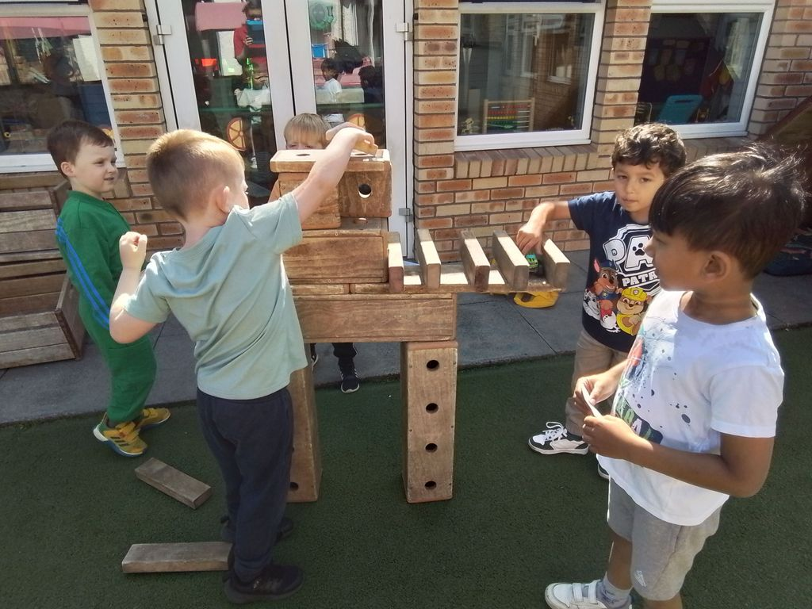
Staff self-evaluation to continually improve practice, Key Worker Review, Peer Assessment & Annual PDR programme
Effective 0-2, 2-3 and 3-5 curricular planning which emphasises the children’s rights to be heard.
Shared understanding from staff re level required for achievement of each milestone. (Moderation)
Provide a high standard of motivational and informative displays.
Learning Journals
Quarterly Parent Council Meetings
Quarterly Pupil Council Meetings
Observation, Moderation and Assessment Activities
Continue to implement ‘MTV’
Partnership working with a range of professionals.
Working with SAC Communication Friendly Team/Training
Frobel in Childhood Practice – University of Edinburgh
Onsite PT & LA PT
UNCRC rights respecting GOLD school award.
Staff engage and use key document to support pedagogy an practice in early level: https://education.gov.scot/improvement/learning-resources/numeracy-professional-learning-resource/

‘Growing Healthy Happy Children’

